**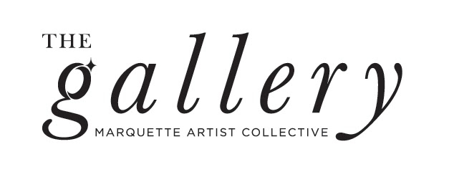**

**130 W. Washington St. Suite U7**

**Marquette, MI 49855**

[**mqtartistcollective@gmail.com**](mailto:mqtartistcollective@gmail.com)

**Show: *Into the Garden***Theme: Artwork representing spring.

Some ideas are spring colors, animals, weather, and flowers.

**Eligibility:** Open to all Marquette Artist Collective Members  
*Must be a MAC Member and have paid the $20 membership fee by February 29th to enter*

*MAC Exhibiting Members commission is 30%*

*Rent Paying Gallery Members commission is 5%*

**Submissions:** All entries must be submitted with this document, filled out including images of art and emailed to Abbigail at: [aatkins@nmu.edu](mailto:aatkins@nmu.edu).   
  
**Timeline:**March 13th, 11:59pm: Entries due

March 17th: Jury decisions sent via email  
March 19th-20th: Artwork due at The Gallery\*

March 22nd-April 19th: Exhibition dates  
April 10th, 6:00-8:00pm: Artist Reception

\**All works must be gallery ready (framed or ready to hang) and delivered during open hours. A signed contract must be filled out upon delivery.*

**130 W Washington St, Suite U7, Marquette, MI 49855**

---------------------------------------------------------------------------------------------------------------------------------

**Exhibition Application**

**Artist Name:   
Date:  
Phone Number:  
Email:**May we add you to our mailing list? (Y) (N)  
May we use images of your artwork for promotional use? (Y) (N)

**Artist Agreement:** I understand and agree that The Gallery: Marquette Artist Collective LLC is not responsible for lost, stolen or damaged artwork. An *Artist Agreement with The Gallery* contract must be signed up dropping work off at The Gallery. The Gallery will take commission on sales. (Rent Paying Gallery Members 5%, MAC Members 30%, non-members 35% - not applicable to this show) **Artist Signature:** *First Name Last Name*

|  |  |
| --- | --- |
| Macintosh HD:Users:sabrinawheeler:Desktop:Langdon_Sabrina_1.jpg  Langdon\_Sabrina\_1.jpg | *----Example----*  **Sabrina Langdon**  *The Beauty of Dissonance Part II,* 2018  Van Dyke Brown Print 20 x 20 inches  **$300**  **Artist Statement:** *The Duality Portrait Series* explores the concept of cognitive dissonance and human complexity through the process of double exposure portraits. |
| Digital File Name | **First Name Last Name**  *Title of Work,* Year made  Medium Size  **$Price or NFS**  **Artist Statement (optional):** |
| Digital File Name | **First Name Last Name**  *Title of Work,* Year made  Medium Size  **$Price or NFS**  **Artist Statement (optional):** |
| Digital File Name | **First Name Last Name**  *Title of Work,* Year made  Medium Size  **$Price or NFS**  **Artist Statement (optional):** |
| Digital File Name | **First Name Last Name**  *Title of Work,* Year made  Medium Size  **$Price or NFS**  **Artist Statement (optional):** |
| Digital File Name | **First Name Last Name**  *Title of Work,* Year made  Medium Size  **$Price or NFS**  **Artist Statement (optional):** |